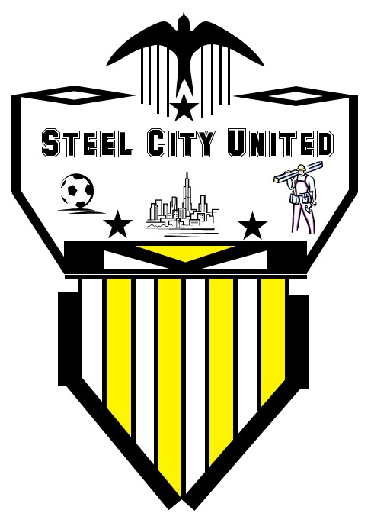

Steel City United
1150 Harvard Dr., Monroeville, Pa 15146

Dear Prospective Team Sponsor:

Our soccer team, Steel City United, is a member of the Greater Pittsburgh Soccer League located in Monroeville, PA. Our team is a self supporting, non-profit group, which must raise all the monies necessary to pay for uniforms, equipment, fields/lights, referees, and league/tournament fees. The entry fee is $100 per player which doesn’t include our uniforms. The team is compiled of men, 21 and over, who have played high school, college, or semi-professional soccer.

In order to meet all expenses, Steel City United, is asking for your tax-deductible contribution to help pay for our uniforms. The uniforms can be chosen by your organization with your logo on the front, and our numbers on the back. The cost is approximately $600 for both home and away uniforms, and $300 for your choice of either the home or away jersey. If you prefer that the team chooses the uniforms, we will submit to you various jersey options, which can be decided on by your company.

These are only a few options that I have suggested, and many more are possible. A collaborative effort will determine the best course of action to benefit both parties involved.

Your advertising options will include, but not limit to:

- Company name on each player’s jersey that will be seen by hundreds of player’s from other teams.
- Meetings before or after each home game at your establishment.
- A secondary sponsor in which your company logo will be printed on the sleeves of each jersey.

Please make checks payable to: Damien Pacchio; 1150 Harvard Dr.; Monroeville, PA 15146 with a copy of this letter having the following information filled out:

Donation amount: $____________________ Donation intended for:_________________________

Your name or company name: ______________________________________________________

Address__________________________________________________ Phone__________________

On behalf of the team, I thank you for your thoughtful gift.
If you have any questions feel free to call
Mike Feezer at 412-856-7739

